# Use case –

Customer can

1. View Service – Static Page which provides information about the services that company provides Example - We provide complete alarm installation system, CCTV Surveillance and Smart Intercom Doorbells. Images to display the services.
2. Request Service – Customer will provide the inputs here.
3. Area – 500 square feet
4. Do you need wired or wireless system – Radio Button Yes or NO
5. Total Number of Doors – 5
6. Entry, exit Doors – 2
7. Number of Open Windows in Home – 8
8. How many open Areas (to detect motion) – 3
9. Do you need CCTV Surveillance? Radio Button Yes or NO
10. If Yes, Ask – How many cameras you need? – 5
11. Do you need Smart Intercom Doorbell? Yes or NO
12. Button that says – Send Quote
13. TextView Saying, we will get back to you with the total cost this service will take.
14. Accept Or Reject Service – Activity showing Cost and all items needed to install (Sent By Admin) and two buttons to accept or reject it. If accepted, Admin will see it under accepted requests and if not it will be rejected.

Admin can

1. View Request- Two types
2. Normal REQUESTS sent by Customer - Requests – Customer1, Customer2………
3. Accepted Requests sent by Customer
4. Approve Request - Send to manager

Manager can

1. Add Employee
2. Assign Job to Employee

Employee can

1. View Job
2. Update Status

**4 USE CASES TO IMPLEMENT**

**Login for all four modules**

Customer – Request Service

Admin – Handle Customer Request

Manager – Assign Job to Employee

Employee – Perform Job

**DATA FLOW**

**Customer UI**

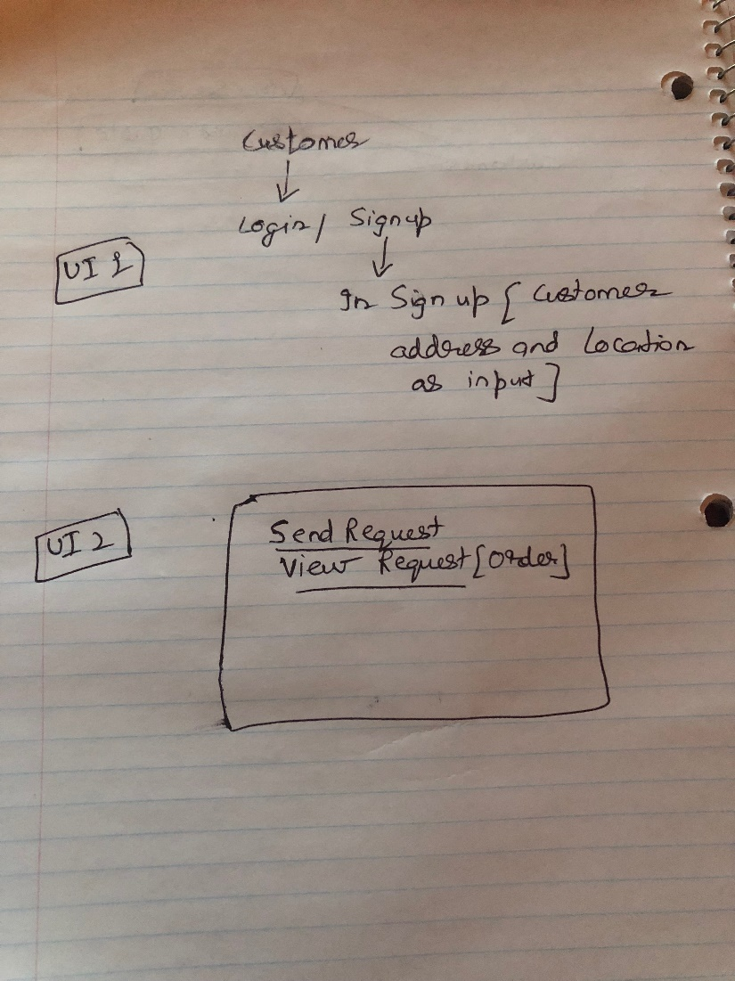

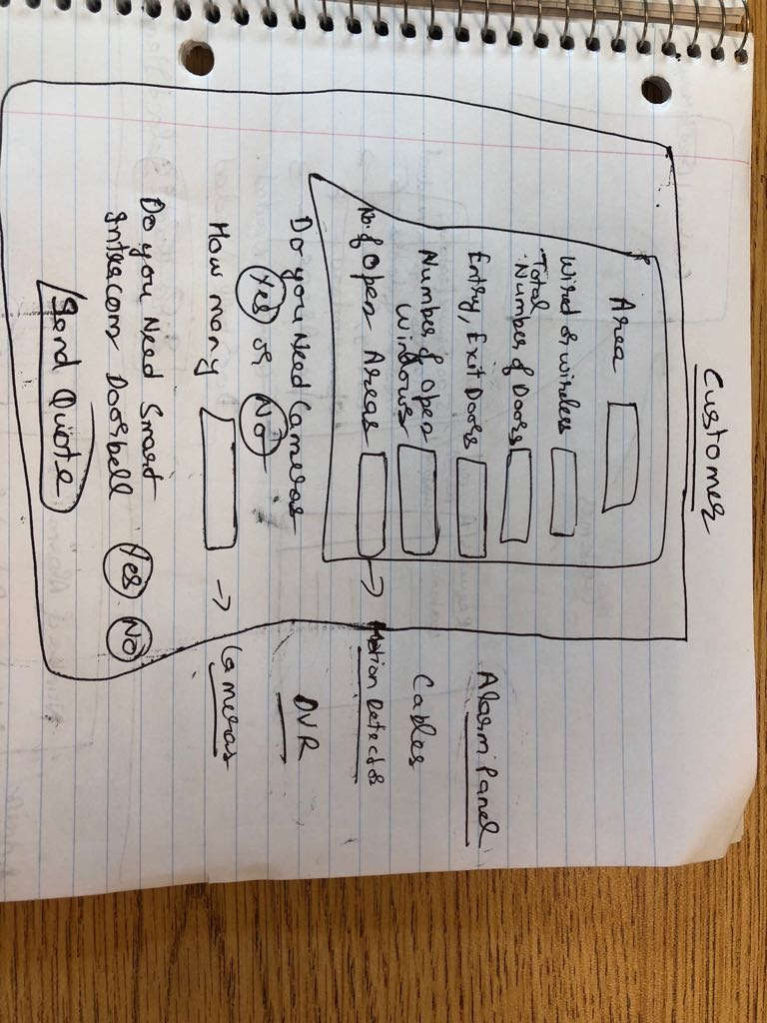

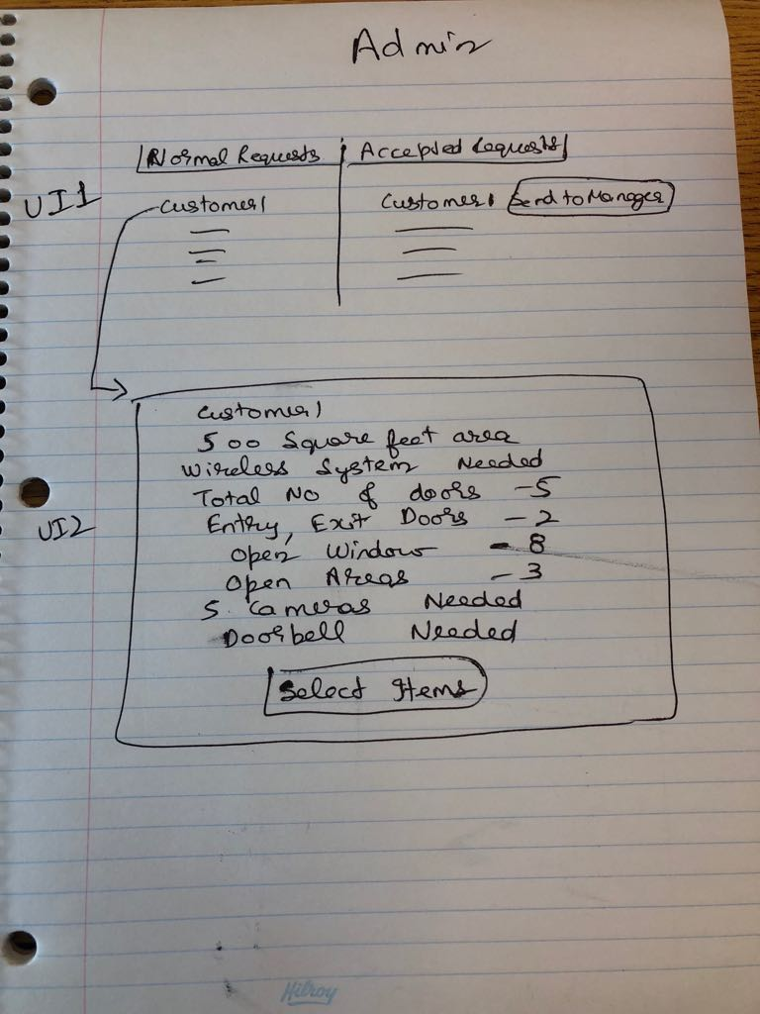

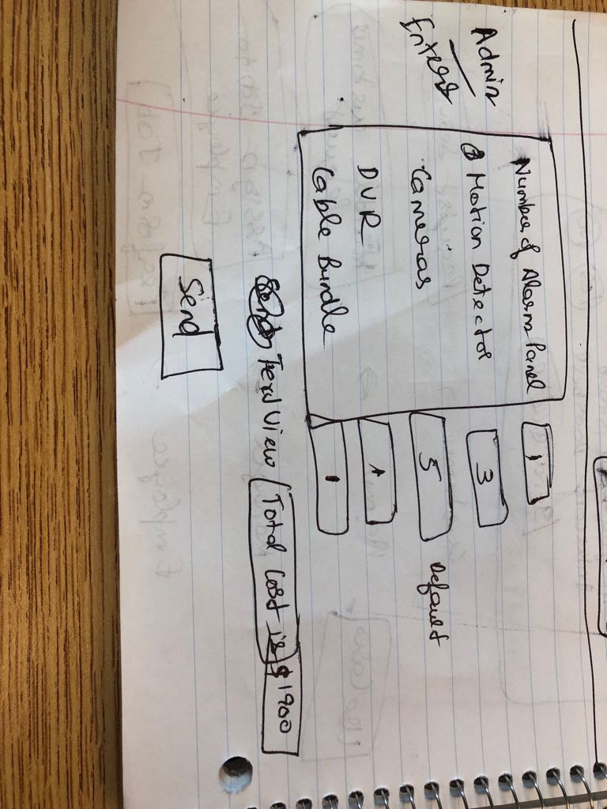

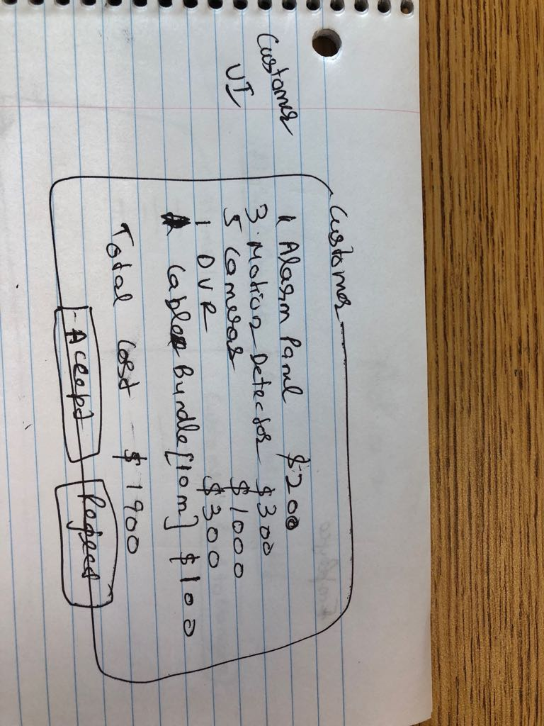

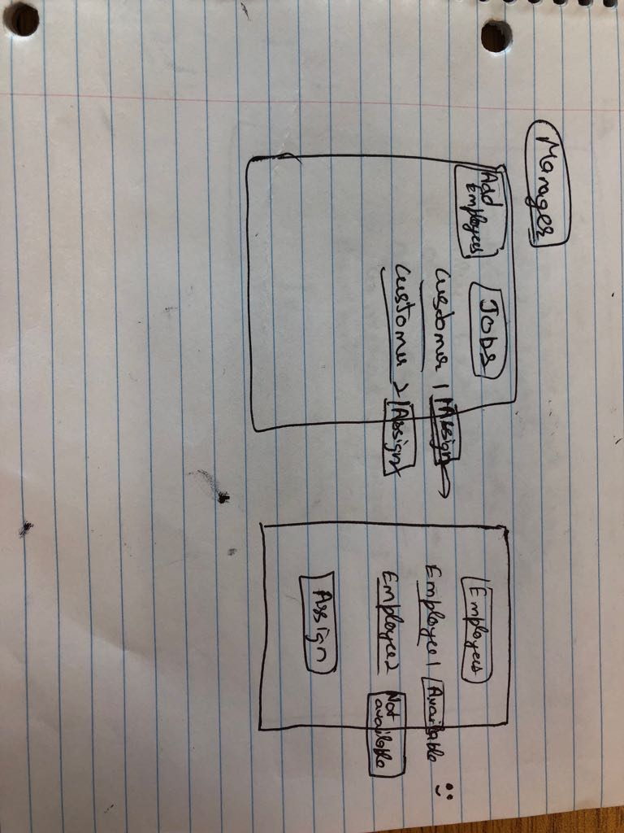

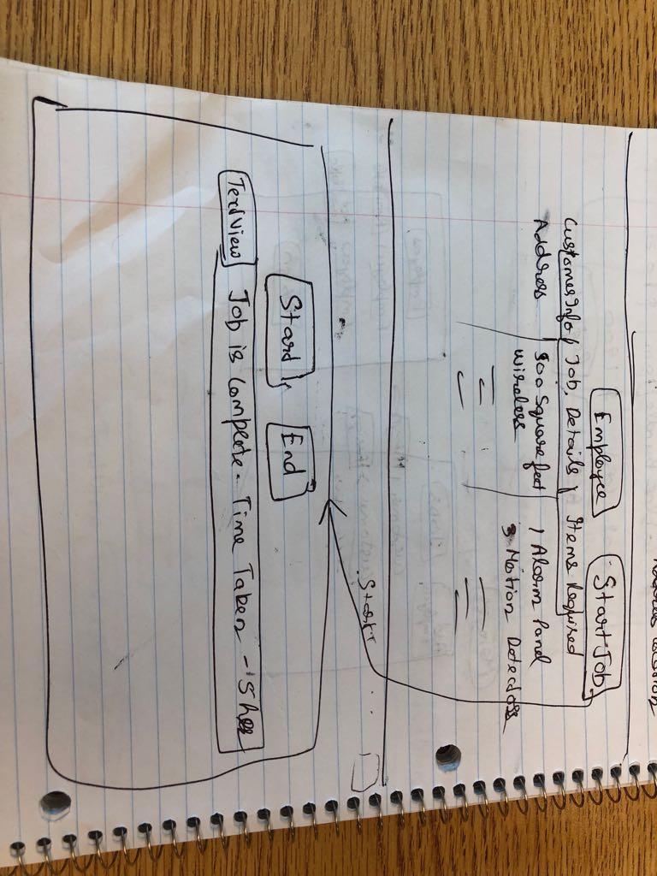

**Notes – when job is complete, employee status becomes available.**

**Customer address information to be taken during sign up – address and location.**

**When job is completed – In admin, Send to manager button text changes to job completed.**

**When job is completed, in manager, assign button text changes to job completed.**